**Homework 1 Application on MATLAB Report**

In this homework we were tasked to enter a number to a graphical user interface designed on MATLAB GUIDE application. When clicked on send push button the entered number on edit text is sent to another GUI. Also, it was a primary task to not to use any kind of global function.

In my research I found that getappdata and setappdata commands can replace the global command in terms of functionality in some cases and in this case, too.   
My Code as Follows:

function pushbutton1_Callback(hObject, eventdata, handles)

% hObject handle to pushbutton1 (see GCBO)

% eventdata reserved - to be defined in a future version of MATLAB

% handles structure with handles and user data (see GUIDATA)

data = get(handles.edit1, 'String');

setappdata(0, 'sharedData', data);

gui2;

I added a data variable which gets the input from edit1, tag of the edit text box, then utilizing setappdata the ‘data’ as to be shared between the GUIs. The ‘0’ is important to be written because lets the ‘data’ reachable between all GUIs. It is also important to note that, if desired the ‘data’ can be used between any GUI.

The changed code in ‘gui2’ is as follows:

function gui2_OpeningFcn(hObject, eventdata, handles, varargin)

% This function has no output args, see OutputFcn.

% hObject handle to figure

% eventdata reserved - to be defined in a future version of MATLAB

% handles structure with handles and user data (see GUIDATA)

% varargin command line arguments to gui2 (see VARARGIN)

% Choose default command line output for gui2

handles.output = hObject;

% Update handles structure

guidata(hObject, handles);

data = getappdata(0, 'sharedData');

set(handles.edit1, 'String', data);

We put the commands under the OpeningFcn because this is what we mainly want the software to do, not some sort of element under GUI like edit text or else.

Again, we defined a ‘data’ variable which takes the other ‘data’ variable with getappdata. Also, if the name of the second variable in GUI was different then the software would not work as intended. The variable name serves as a key. This lets other information than ‘data’ to be shared between GUIs. So, this way, the code settappdata and getappdata can be used multiple times in a specialized way for every information and GUI in a complex system respectively. These commands give freedom of use of information in complex systems. This is the key difference between global and the other method appdata commands.

My Thoughts about this Homework:  
At the beginning I thought and objected that if we have a way to do the task why other. But while researching and after finding these commands I hopefully realized the intention behind “the other method”. I find the other method quite useful. When I need I use global command, because it is needed for every single GUI in my potential complex project. While on the other hand the appdata commands can be used for special data that is needed only for once between two or more GUIs. I also find useful to learn such a information in a simple task. In a big GUI project this problem may become a headache.   
On the other hand, MATLAB provides a ease of use with these commands because what I heard is in some other applications, like AI or robotics, it is a hurdle to transfer data between different software aka GUIs.

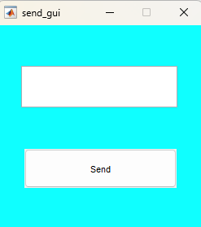

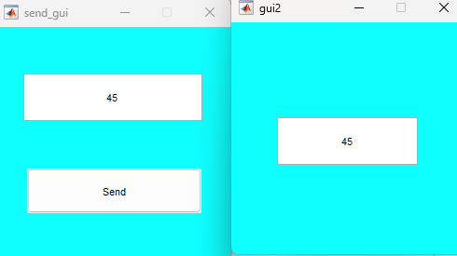

Mustafa YILDIRIM 19050211024